Handling and Validating Checkbox Button

WebUI.verifyElementChecked(findTestObject('CHS_Appointment_OR/Page_CURA Healthcare Service/input_hospital_readmission'),

0)

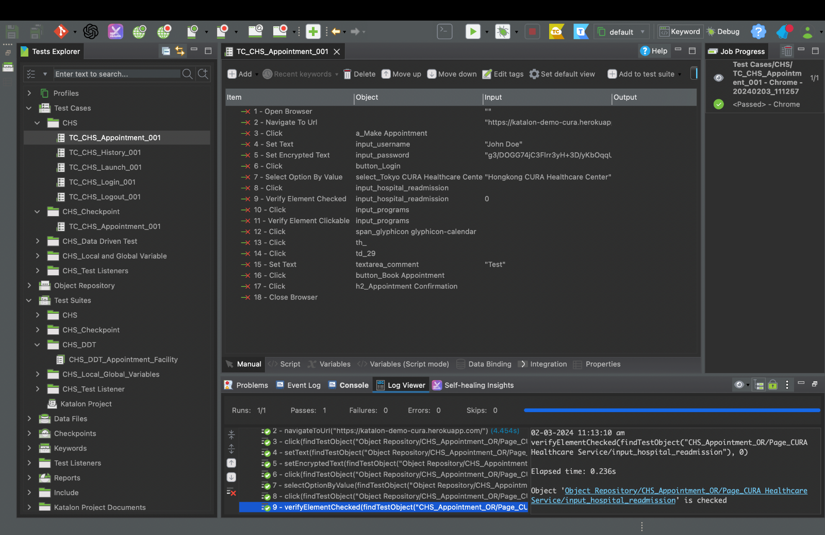

Handling and Validating Dropdown Buttons

Dropdown button was validated using keywords

@Keyword

def CheckDropDownListElementExists(TestObject object, String option) {

boolean flag = false

WebElement element = WebUiBuiltInKeywords.findWebElement(object, 20)

Select ddl = new Select(element)

for (WebElement ele : ddl.getOptions()) {

if (ele.getText().equals(option)) {

System.out.println("Element Exists")

flag = true

} else {

System.out.println("Element not Exists")

}

}

return flag

}

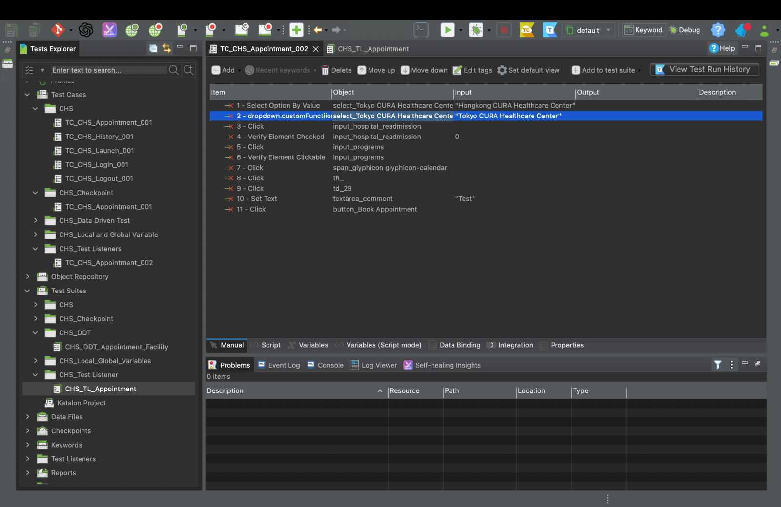

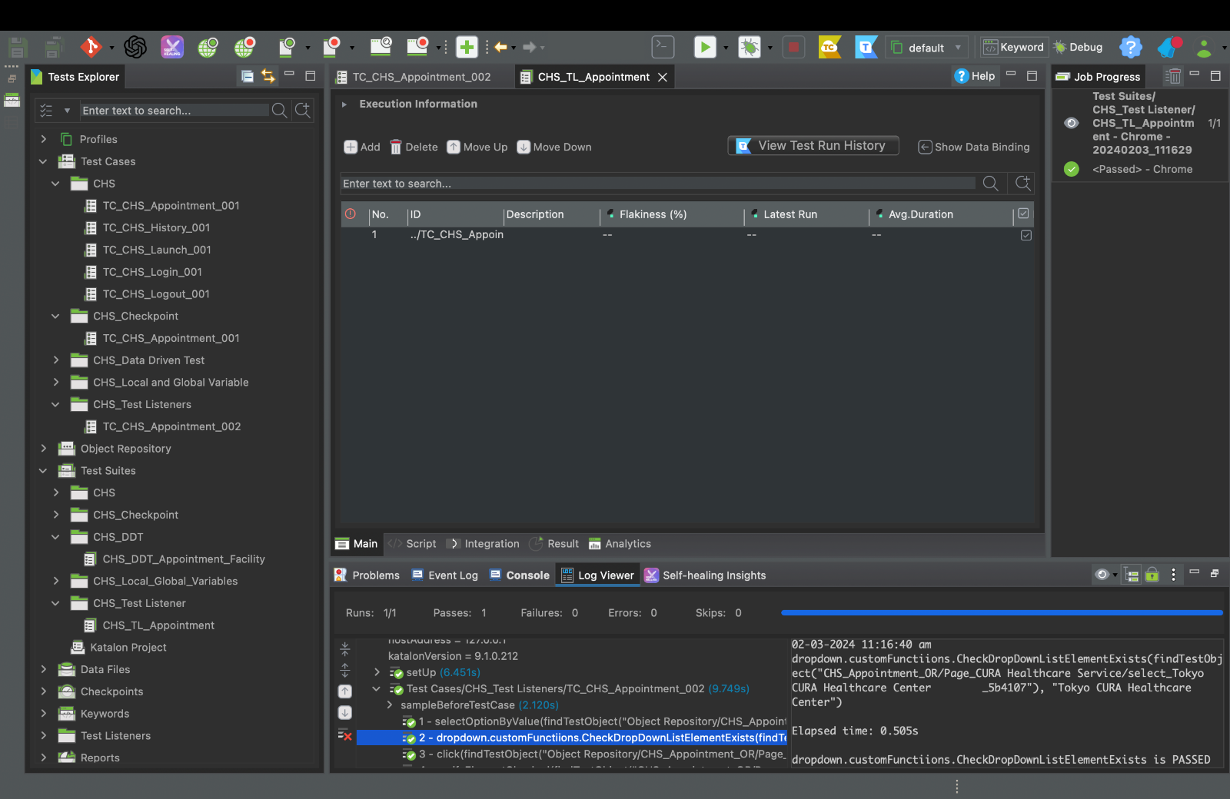

Handling and Validating Input or Radio Button

WebUI.verifyElementClickable(findTestObject('CHS_Appointment_OR/Page_CURA Healthcare Service/input_programs'))

